

Oversteering

# Shows Relationship Between All Four Tires During Various Conditions

Supplies: Create a PowerPoint showing the footprints made by the tires during various maneuvers. On the second one, remove the description of the tire footprint. Show the transparency and ask what maneuver the vehicle is making. Confirm the answers by showing the first transparency with the answers.

Instructions:

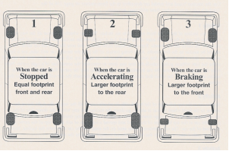

Examples of oversteering

# Handle A Rear Wheel Skid With Targeting Skills. Developing Vision, Motion, and Steering Sequence

Supplies: Chair that can swivel, simulated steering wheel. Student needs to recognize oversteer as rear wheel loss of traction. Response: Steer back to target, progressive acceleration brake get rolling traction established (using TCS or ESC if equipped), and keep steering gently and efficiently to path of travel and target area.

Instructions:

Assign a student to sit in the chair that can swivel, holding a simulated steering wheel.

* Tell the student to pretend they are driving.
* Explain that in this simulation the intended path of travel is toward the target (select one in the classroom, such as the door.)
* Tell the student to keep the vehicle on target, and as soon as the vehicle gets off target, turn the steering wheel to get the front of the vehicle back on target. Remind that a slight steering effort is all that is necessary. If the vehicle begins to move quickly off target, a slight acceleration, and turning of the wheel would be necessary to get the tires back on target.
* Stand to the rear of the chair and swing the chair slightly off target in one direction or the other. Observe how the student responds with steering and head movement toward the target.
* Swing the chair again, changing the direction and quickness.
* Ask students to provide feedback about the driver’s head position and direction, speed and the extent of the steering wheel turns.